COVID-19 Vaccine Myths Versus Facts for Beginning-Level ELLs
Purpose
To present a lesson on vaccine myths versus facts, focusing on the COVID-19 vaccine.
Rationale
COVID-19 vaccine hesitancy remains a concern in the U.S., even though 51% of the country was fully vaccinated as of mid-August. Vaccine hesitancy may be a greater issue among adult education students for a few reasons:
• They may have misunderstandings about the vaccine and how it works.
• Their busy lives make it harder to take the time to get a vaccine.
• They are afraid of the side effects that some people experience.
• Some may be wary because of how vaccines have been used in the past among certain populations.
• English language learners (ELLs) may not have enough information about the vaccine in their native language.
Vaccine hesitancy has been a concern for literacy program tutors, teachers, and directors planning to start in-person classes again in the Fall.
Vaccine knowledge is important beyond protection against COVID-19. Going into the flu season, learners should be aware of vaccines that protect against the flu. In addition, vaccines that protect against shingles, pneumonia, and various childhood diseases are relevant for some student populations.
The activity that follows helps introduce COVID-19 vaccine myths and facts. It is best geared toward beginning-level ELLs, although teachers and tutors can adapt it for other levels.

The Basic Activity
1. Have the handout on page 3 of this issue ready to share, either electronically or in print.
2. Before class, find out where the COVID-19 vaccine is currently available in your area. You can check this on the website Vaccine.gov.
3. Ask students: “What do you know about COVID-19? How can you stop COVID-19?” Elicit answers. Be ready with any visuals or physical gestures to help reinforce concepts that come up, such as distancing and washing hands.
4. If students do not mention the vaccine, bring it up. Let them know the vaccine is a shot. It stops you from getting sick. Ask: “Do you know of other vaccines?” Listen to responses and add some basic responses of your own, such as flu, pneumonia, and tuberculosis (TB) vaccines.
5. Ask: “What do you know about the COVID vaccine?” Discuss any responses.
6. Let the class know they will learn what is true and not true about the COVID-19 vaccine. On the board, write the words myth and fact. Let them know a myth is not true. You can reinforce this by shaking your head no, writing an "X", or doing a thumbs-down gesture. Then let them know a fact is true. You can reinforce this by nodding yes, writing a check mark, or making a thumbs-up gesture.
7. Share the handout from page 3. Read the title. Give students some time to look at the handout on their own. Then review it together as a class. Go over any new words.
8. When finished, ask: “What questions do you still have about the vaccine?” Make a list of any questions that come up. You may not be able to answer the questions in class immediately, but it gives you some ideas for future classes.
9. Ask: “Do you need help finding a vaccine?” This is where information on local vaccination locations—available on Vaccine.gov—can be helpful. You can let students know where to go.
Note: You can also let students know that getting the COVID-19 vaccine is a choice. Many people, including many doctors, think it is good and stops COVID-19. Other people may choose not to get a shot. Depending on your students' proficiency, you can also discuss any consequences of not getting a shot and any COVID-19 variants in your area, such as the Delta variant.

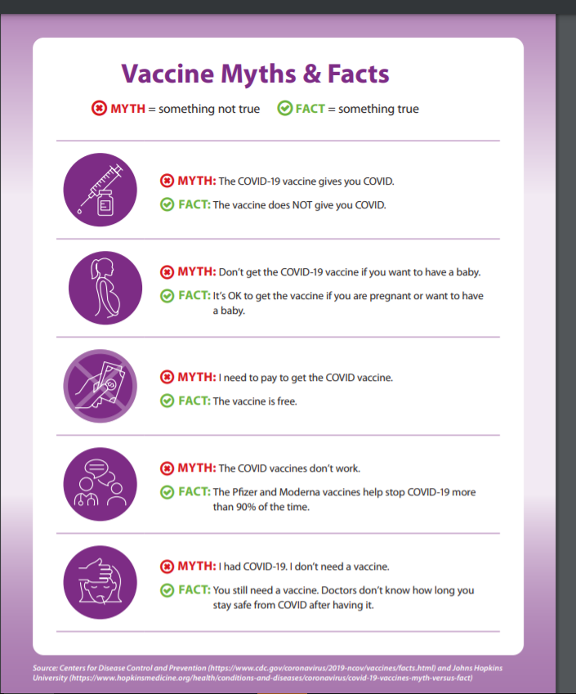
Additional Resources:
COVID-19 Resources for Adult Learners
https://floridaliteracy.org/coronavirus.html
https://floridaliteracy.org/pdf-docs/vaccine-myths-Literacy-Council-Sarasota.pdf
The Florida Literacy Coalition has a webpage dedicated to coronavirus resources, most of which teachers and tutors can use anywhere around the U.S. The web page includes the Florida Literacy Coalition’s coronavirus lesson plan and a tab with vaccine educational resources. The second link above is information on vaccine myths, created by the Literacy Council of Sarasota. This information could be used with high intermediate/ advanced ELLs or pre-high-school equivalency (HSE) students.
COVID Vaccine Hesitancy
https://www.beaumont.org/health-wellness/blogs/covid-19-vaccine-hesitancy-addressing-common-concerns
https://www.usatoday.com/story/news/2021/02/16/black-history-covid-vaccine-fears-medical-experiments/4358844001/
https://apnews.com/article/language-migrant-workers-immigration-coronavirus-pandemic-california-4565a299c825f013ee43d07cdfa019a8
These three resources share information on addressing vaccine hesitancy and why some population groups may be more vaccine-wary.

