Managing the Classroom for ALL Students
Purpose
To promote teaching approaches that help all students, including those with potential learning disabilities, better understand class material.
Rationale
The federal government estimates that 1 in 5 people in the United States has a learning disability. The range of learning disabilities that affect classroom work and instruction is quite broad but can include dyslexia (problems with reading), dysgraphia (problems with writing), and dyscalcula (problems with math). Some adult students may have behavioral-related challenges, such as attention deficit/ hyperactivity disorder (ADHD/ADD) or Asperger’s syndrome, that affect their ability to focus in class or at work. Many (if not most) adult education programs do not have the funding to identify and diagnose students with learning disabilities, leaving teachers or tutors to find ways to reach these students effectively. These students may have struggled with learning in K–12 settings as well and come to the adult classroom with a sense of frustration. This professional development article focuses on ways to design your instruction so you can more effectively teach all types of students, including those who may have learning disabilities. Using these techniques will likely make for better instruction for all of your students.
Supporting a Stronger Classroom for All Students
1. Ask students how they think they learn best. There are various assessments online, both long and short, to assess learning styles. However, learning disabilities expert Laura Digalbo, of Burlington, Connecticut, who facilitated the LINCS Community discussion, shares one easy way to broach this topic at a basic level:
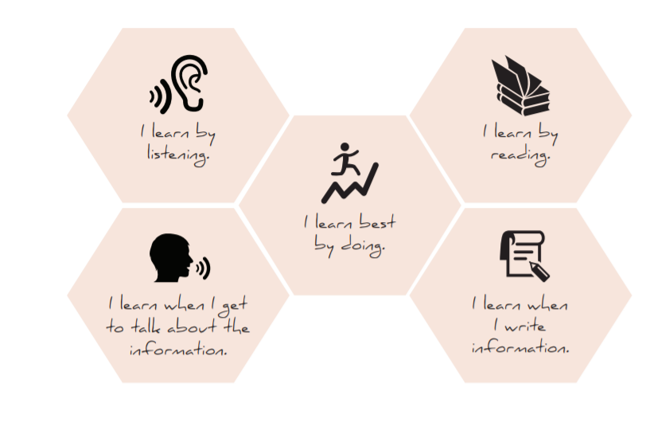
By asking students which way they learn best, you know how to best address their learning needs.
2. Demonstrate what you are teaching in multimodal dimensions. Don’t just talk about what you want students to learn. Write it down on the board or projected computer screen, and then also demonstrate it if applicable. Try to reach students who have various learning styles (e.g., visual, auditory, kinesthetic).
3. Break activities into smaller time chunks. For students who you suspect might have ADHD/ADD, giving them extra time to complete activities may not be effective. Instead, break the activity into smaller time chunks, so they are able to work briefly, take a break, work again briefly, and then take another break. Continue with this approach until the activity is finished.
4. Eliminate visual distractions. Although teachers want to provide a stimulating classroom environment, it’s also possible to provide overstimulation. Take a look around your classroom and consider if any visual distracters keep students from focusing on important class-related material. It may be as simple as making sure you don’t have too much text on the board.
5. Tell students what to expect during a lesson. By preparing students with a short written and spoken agenda, you’ll reduce anxiety. You could even give out a short handout with bullet points to explain the class plan for the day.
6. Give instructions in the simplest form possible. Even if you want to boost language or technical sophistication over time, you’ll find students are better able to follow the class with simple instructions on how to complete a task.
7. Give students additional time to process new information or ask questions. Due to language challenges (especially in an ESOL environment), trauma, inefficient learning in the past, or even poverty, students may have different information-processing speeds. When you ask a question of the class or you want them to ask you questions about new information, don’t assume silence equals comprehension. Take an extra minute or so to allow everyone to process your questions.
8. Provide structured choices to complete certain assignments. For example, if your class is reviewing a lesson related to workplace vocabulary, decide in advance on two or three options that will help them effectively review the vocabulary. Maybe they can choose to write sentences with the vocabulary, practice saying the words aloud with a partner, or review flashcards with the words. You may structure the lesson so students still have to do all modes of practice, but they have a choice regarding mode they will complete first.
9. Use graphic organizers. Hand out copies of outlines, charts, or webs that will assist all students, but especially those who need extra help organizing information. A web search for “graphic organizers” will yield a variety of ideas. See an example below for a Venn diagram, which students can use to organize how two things are different and, in the middle, how they are the same. The example below compares two students who may be discussing their likes and dislikes.
10. Provide immediate, genuine, positive feedback. Immediate feedback lets students realize how something they have said or done works successfully in the class environment. Although you’ll want to praise students frequently (many students with learning disabilities may need that extra praise), you also want to make sure the praise is genuine.

