Encouraging Self-Reflection on Lessons
Purpose
To present three ways to encourage more student self-reflection on what they have learned.
Rationale
Think about the typical parts of a lesson: introduction, presentation, practice, independent practice, and assessment. In the rush of teaching, it may be easy to ignore another step: reflection. Reflection gives students time to consider what they’ve learned and how they will apply it in the future. Reflection is often an underappreciated, but still valuable, part of a lesson. Classroom What are some ways to encourage students to practice reflection after a lesson in an adult literacy setting? Here are a few examples.
The Basic Activities
The Exit Ticket
An exit ticket is a short document with a prompt or two for students to reflect on what they learned during class. The idea is for students to jot some quick thoughts at the end of class. On your exit ticket, include one or two questions that encourage self-reflection from students. Some example questions include:
• Name one important thing you learned in class today.
• How will you apply what you learned today?
• What questions do you still have about our lesson?
• How could today’s class have been improved?
Provide students with a few minutes at the end of class to complete their exit ticket. Collect the exit tickets as students leave class. You also could have students huddle together briefly to discuss their responses. If you are meeting virtually, students can complete their virtual exit ticket in the chat function. Use exit ticket feedback to see what students picked up the most from your lessons and to assess any room for improvement in your teaching.

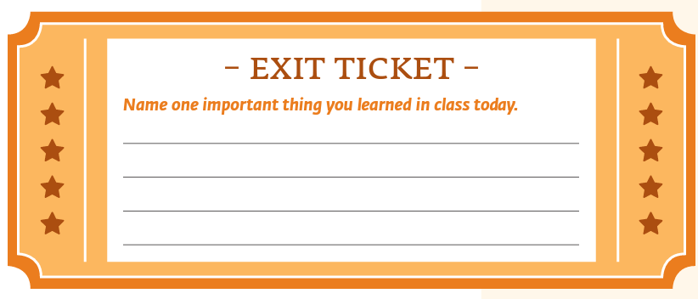
Reflective Journaling
With this approach, students keep a journal to reflect on what they’ve learned. You can use this several ways:
• Have scheduled time at the end of each class for students to write in a journal about what they learned that day. Or they can write in their journal about what remaining questions they have related to the lesson.
• You could ask students to write in their journal outside of class, as homework.
• Decide how you want to review reflective journal entries. Will you collect journals once a week/month to review what students wrote? Do you plan to provide a lot of feedback or just check to show that you saw what they wrote? Let students know your expectations.
• You can provide a variety of questions related to self-reflection for students to respond to, just as you might vary the questions used for exit tickets. Students can keep a journal electronically or on paper. They also could keep a blog with what they wrote, even if they set it up so it’s private. If you have students hesitant to journal frequently, consider the option of a short video they could create and share with you.
Students can keep a journal electronically or on paper. They also could keep a blog with what they wrote, even if they set it up so it’s private. If you have students hesitant to journal frequently, consider the option of a short video they could create and share with you.
Show of Hands
For a quick reflection that doesn’t involve paper or technology, you can ask for a show of hands. Have specific yes/no questions in mind that still require reflection from students. Some examples might be:
• Did this lesson help you better understand (insert subject matter here)?
• Was the lesson easy to follow?
• Do you have other questions about the lesson?

A Few Tips for Using Self-Reflection Activities
• Let students know that they won’t be graded on their responses. You may decide to grade them or give them credit for completing their exit tickets or reflective journaling, but students should be able to reflect on lessons as they see fit.
• Good learners take the time to reflect on what they’ve learned in any setting and consider how they can apply it elsewhere in their life. This helps them learn to reflect not just on your classroom lessons but in other facets of life. Reinforce this with students as you incorporate more self-reflection into lessons.
• Decide if you want students to write their name on their exit tickets. If you are giving them credit for completing it, then they should have their name on it. Otherwise, you may want to offer the option of an anonymous response.
• Consider adding reflection to the beginning of the next lesson. When you start class, you can ask students what they learned from the previous class. Or you can ask, “What do you remember about (insert lesson topic here)?”
• Use self-reflection tools consistently. This gets students in the habit of reflecting.
• Change up your self-reflection questions from time to time

