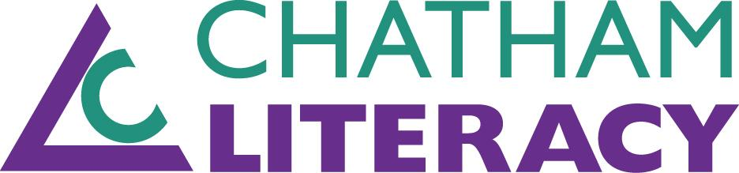
Monthly Tutor Report
Month: ___________ Year: _____

Tutor: | Tutor Site/Day/Time (ex: PBO/T-Th/6p-8p):
Students(s):

Please indicate time to the nearest quarter hour, in decimal points (1.25, 1.5, 1.75).
Date | Prep Time | Travel Time | Tutoring Time | Student(s)

Please enter student initials or number from above in the grey box to the left of any goal that applies to your student(s). Note any specific accomplishments on the next page.
Student Short-Term Goals Met Student Long-Term Goals Met
 | Improved conversation skills |  | 90% attendance for 9 months
 | Improved listening skills |  | Ready to review for citizenship interview
 | Increased vocabulary |  | Obtained citizenship
 | Improved accent/pronunciation |  | Voted in an election
 | Improved reading --sounding out words |  | Passed GED RLA content
 | Improved reading--understanding text |  | Passed GED Math content
 | Improved writing skills |  | Passed GED Science content
 | Improved math skills |  | Passed GED Social Studies content
 | Improved job skills |  | Passed entire GED
 | Involved in child(ren)’s education |  | Entered training for job/volunteerism
 | Involved in community |  | Completed training for job/volunteerism
 | Increased ability to converse by phone |  | Obtained a job
 | Increased understanding of radio |  | Earned a job promotion
 | Increased understanding of TV |  | Obtained a library card
 | Increased citizenship knowledge |  | Obtained a driver’s license
 | Improved computer skills |  | Became a committee/board member
 | Other: |  | Other:

