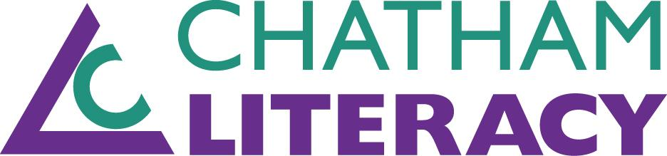
CASAS Online Training

Instructions for online CASAS (Comprehensive Adult Student Assessment Systems) course for test administration. This course takes approximately 3-5 hours to complete. Upon completion you will be a certified Proctor for Chatham Literacy. Thank you so much for taking the time and effort to become such a valuable volunteer.

On the CASAS website you will be creating an account for yourself, registering for the online course, and then taking the course. Following is the list of steps necessary to accomplish this. We are sorry for the cumbersome nature of these procedures, but we are at the mercy of CASAS.

- Prep your computer for working on the CASAS website OPTIONAL
  - On your internet screen, select the tools gear icon (typically at the top right of your screen - when you hover your cursor/pointer over the gear icon it should say ‘tools’)
  - Drop down and select ‘Compatibility View settings’
  - Type ‘www.casas.org’ in the “Add this website:” box and select the ADD button
  - Select Close when you see casas.org has been added in your safe websites box
  - If you’re using Chrome, click the the three vertical dots on the top right of your screen
  - Click on Settings
  - On the left of your screen, click Privacy & Security
  - Scroll down, until you see “Privacy & Security”
  - Click on Site Settings> Pop-Up & Redirects>Allow: type “www.casas.org”

- Create your account on the Homepage of the CASAS website, www.casas.org.
  - Select ‘Create Account’ which appears at the top center of the website
  - Fill out all fields with an * including your preferred email address and a password of your choice
  - The Organization Name is Chatham County Literacy Council
  - The Zip Code is 27312
  - Our Organization Category is Education Provider
  - Once you have completed your account information CASAS will send you an automated email to the e-mail address you provided (NOTE: if you have NOT received it within 15 minutes please check your SPAM folder in case it landed there) From that email you will confirm and activate your new account with CASAS by selecting the hyperlink imbedded within the email

- Login to your CASAS account on the Homepage, www.casas.org
  - Select ‘Login’ (which appears at the top to the left of the ‘Create Account’ option)
  - Type in your email address and password you created in the steps above
  - The Homepage ‘Login’ should now say ‘Welcome, yourname’

- Register for the course on the Homepage
- Under ‘Welcome to CASAS’ Select the ‘Online Training’ box (3rd one down)
- This will automatically send you to a new tab with all the trainings CASAS offers
- Scroll down until you find the training, “CASAS Paper Test Implementation”
- Click on Module 3: Paper Test Implementation
- This will take you to the Training
- To begin click on ‘About this Course’
- Much Congratulations! You are now ready to take the course.

- Important NOTES:
  - There are online assessments for each unit in the Module. There are 6 units
  - To pass the course, you must get a 100% passing grade on each unit assessment
  - You have unlimited attempts for the assessment
  - Click on the arrows on the top and bottom of the page to go to the next or previous slide
  - To leave the course, you close the tab. CASAS will save your progress
  - To return, Login on the Homepage> select ‘Online Training’ box, this will send you to another tab/web page>Click on ‘Log In’ on the top right of your screen> click ‘Dashboard’>Click on Module 3: Paper Test Implementation
  - To track your progress, each unit has a checkbox on the right. If you have completed the unit, there should be a check on the box. You can also check by looking at the ‘Progress Bar’ on the top left corner of the page

- You can now begin (YEAH!!!!)
- You are free to take the course at your own pace
- This course is about testing logistics, not about tutoring itself
- You should be able to leave at logical breaks in this course and return where you left off
- You will submit a Test Security Agreement at the end of the course. Please read the agreement
- You will receive a certificate of completion through email once you have completed the training. Please Forward the email to us.
- If you have questions or concerns, please contact techsupport@casas.org or 800-255-1036, option 2

Hope you enjoy the course. Again, thank you so much for taking on this important role in our organization!

