How to create a zoom account:

- Go to zoom.us
- Click the blue, ‘sign up free’, in the upper right hand corner.
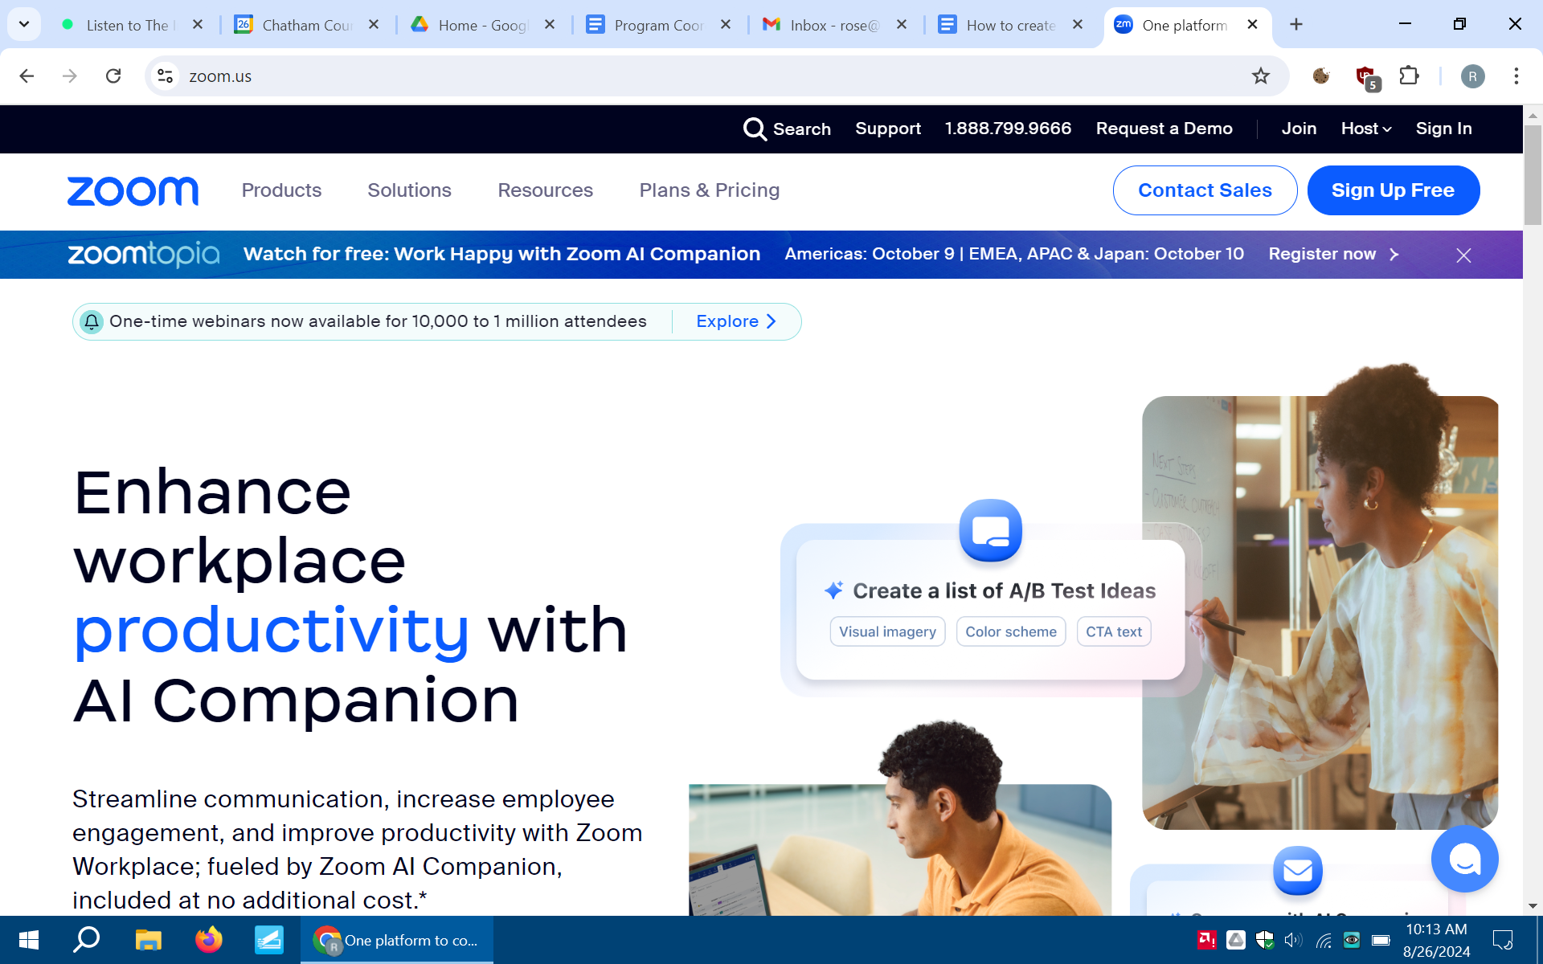

- You will be redirected to a page where you can create your free Basic account. It says, ‘verify your age’.
  - Enter your birth year.
  - Click the blue, ‘continue’ button to proceed.
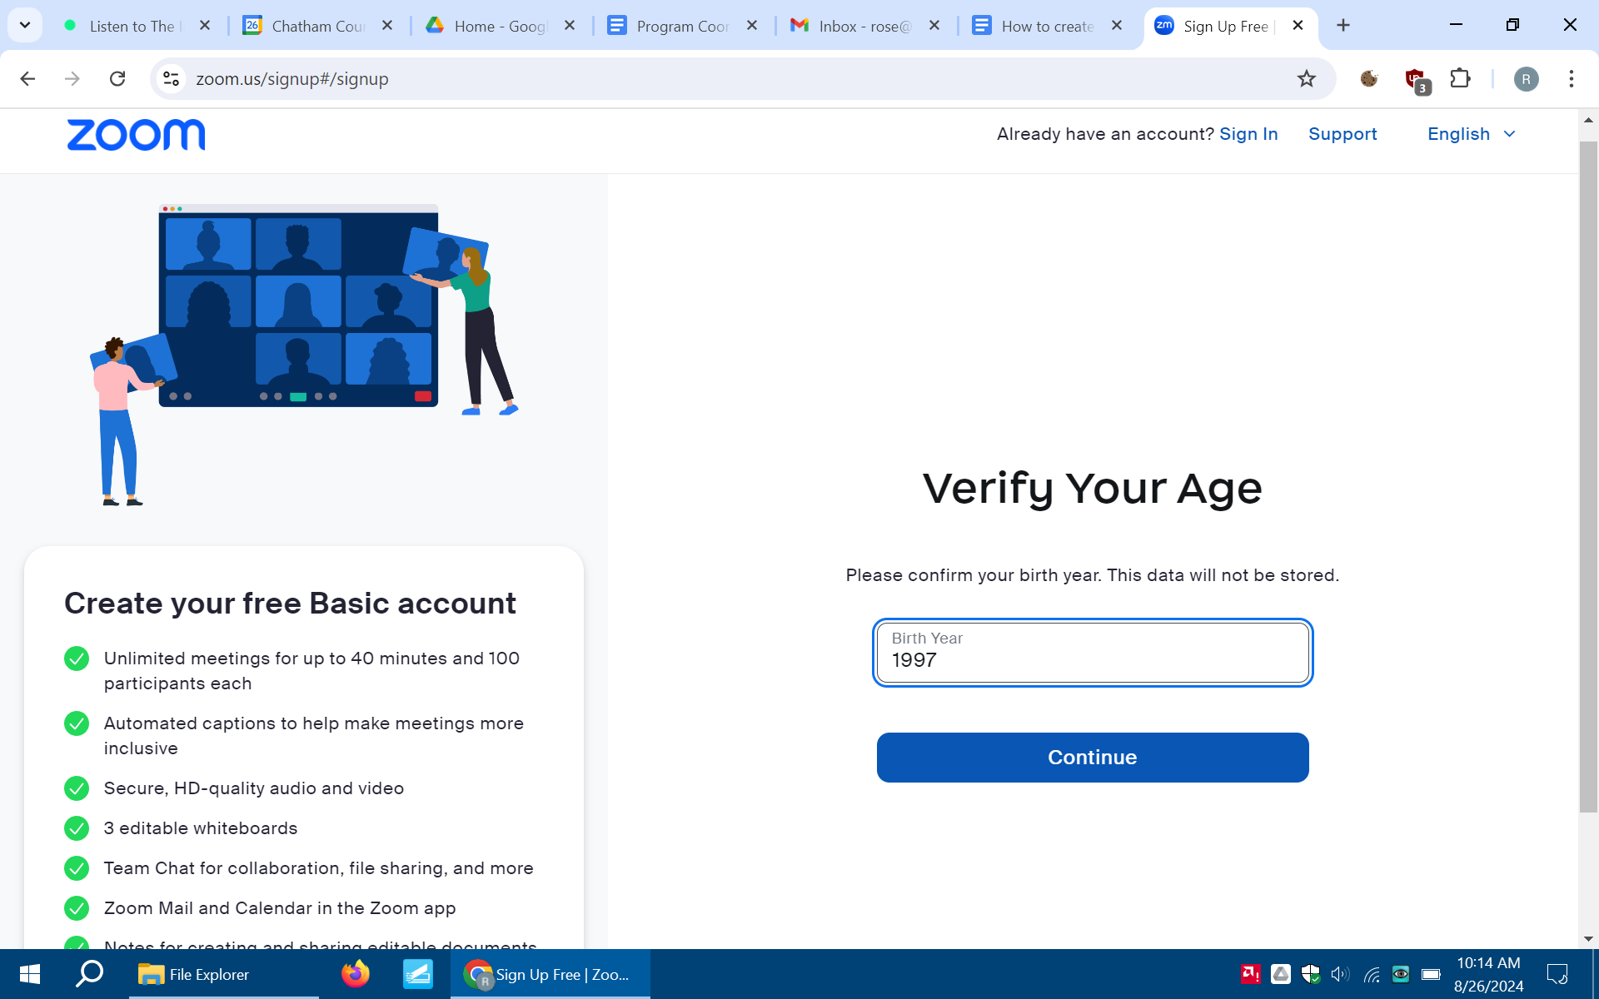

- Next, the page will say ‘Let’s Get Started’
  - Enter your personal email address- PLEASE make sure you have access to this email address.
  - Click the blue ‘continue’ button to proceed.
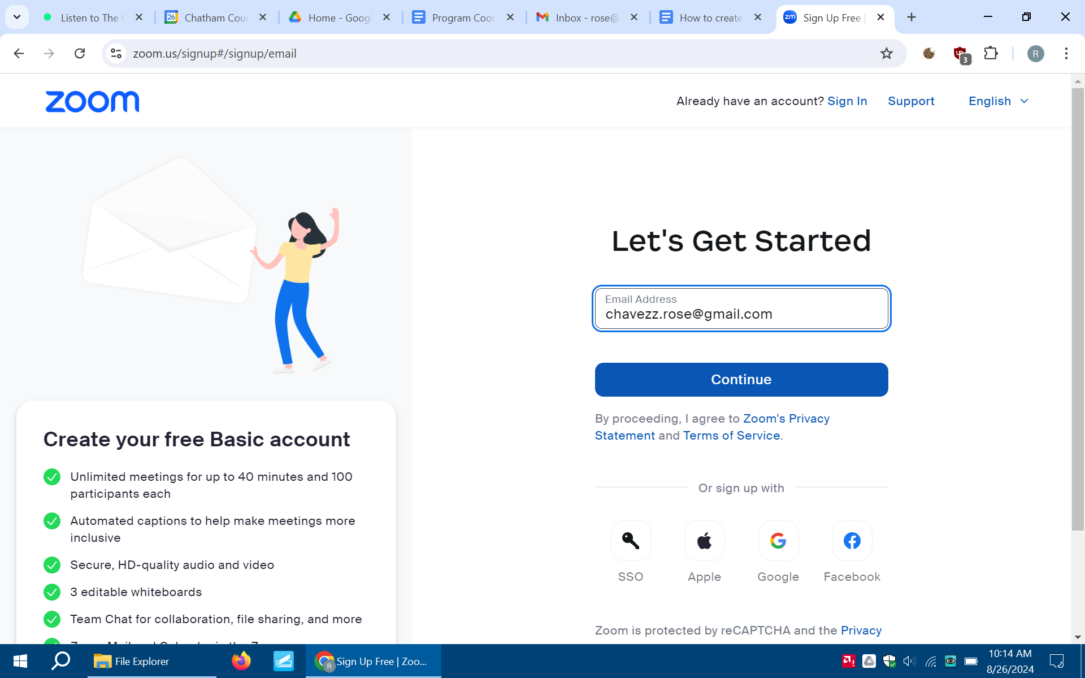

- Next, the page will say ‘Check Your Email for a Code’.
  - You will need to check your personal email address for a code.
  - When you find the code in your personal email address, go back to Zoom and enter the code in the boxes.
  - Click the blue ‘continue’ button to proceed.
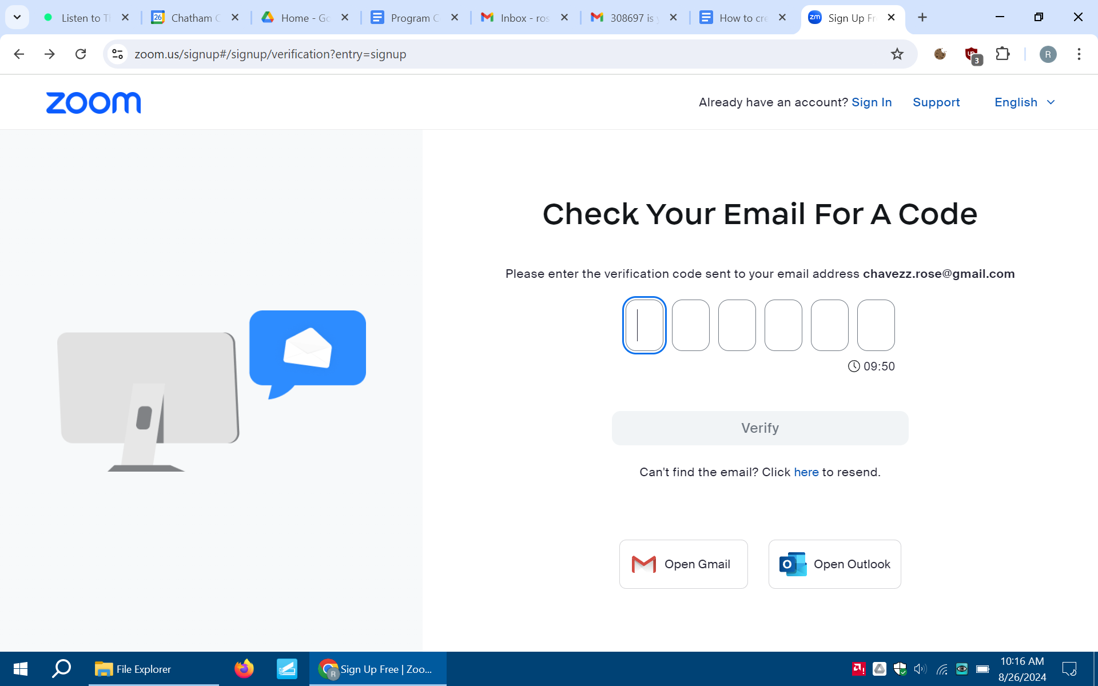

- Next, the page will say ‘Create Your Account’.
  - A password will need to be set for your new Zoom account.
  - Click the blue, ‘continue button to proceed.
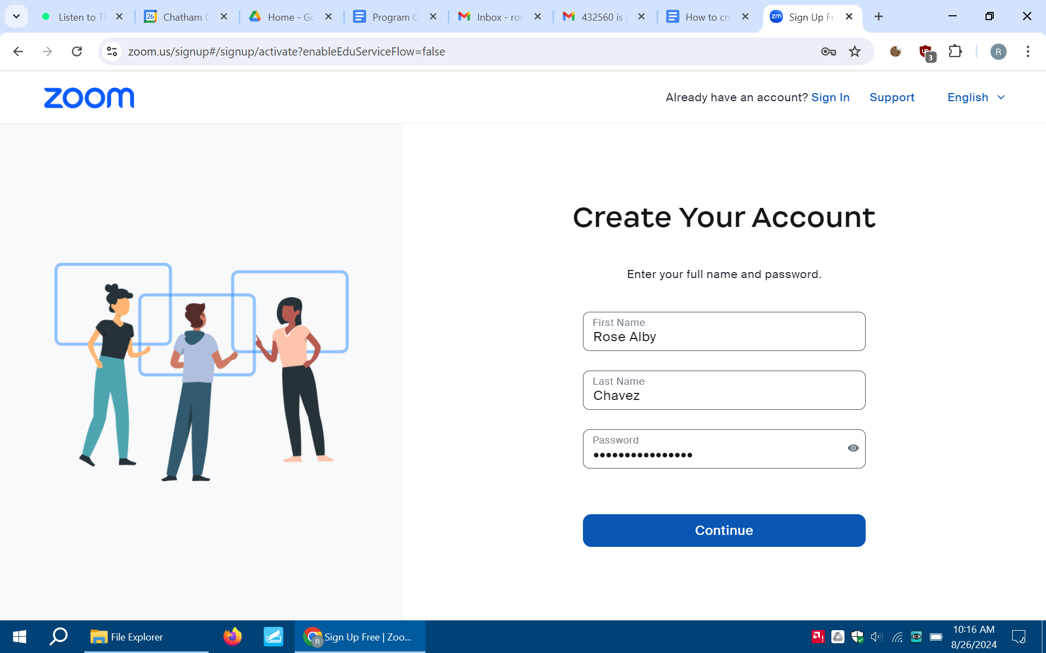

- Once the page has finished loading, a pop-up window will appear. To avoid getting text alerts, click ‘No Thanks’ in the bottom right, hand corner.
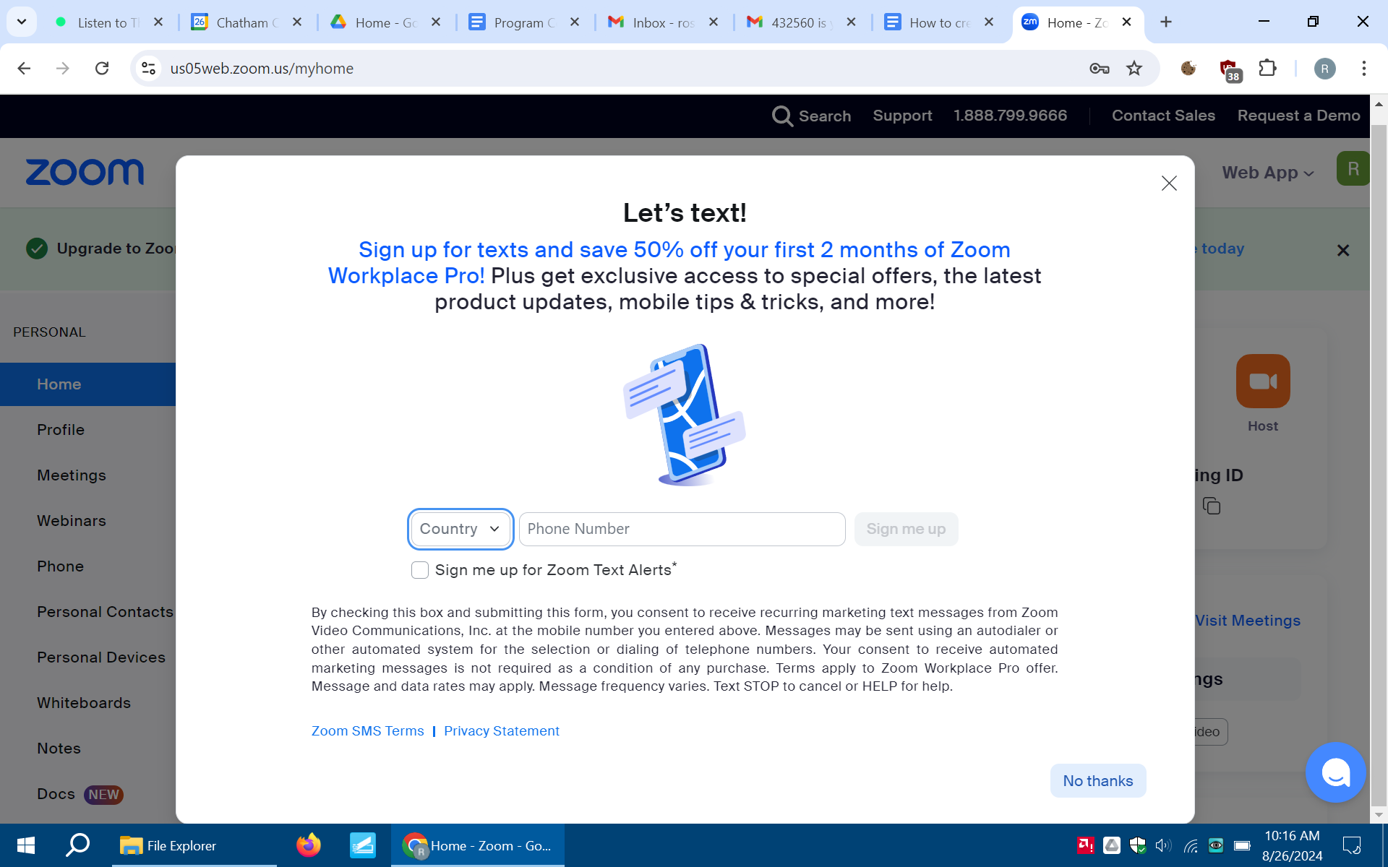
- Once you clear the pop-up box, you will see your account with your name. 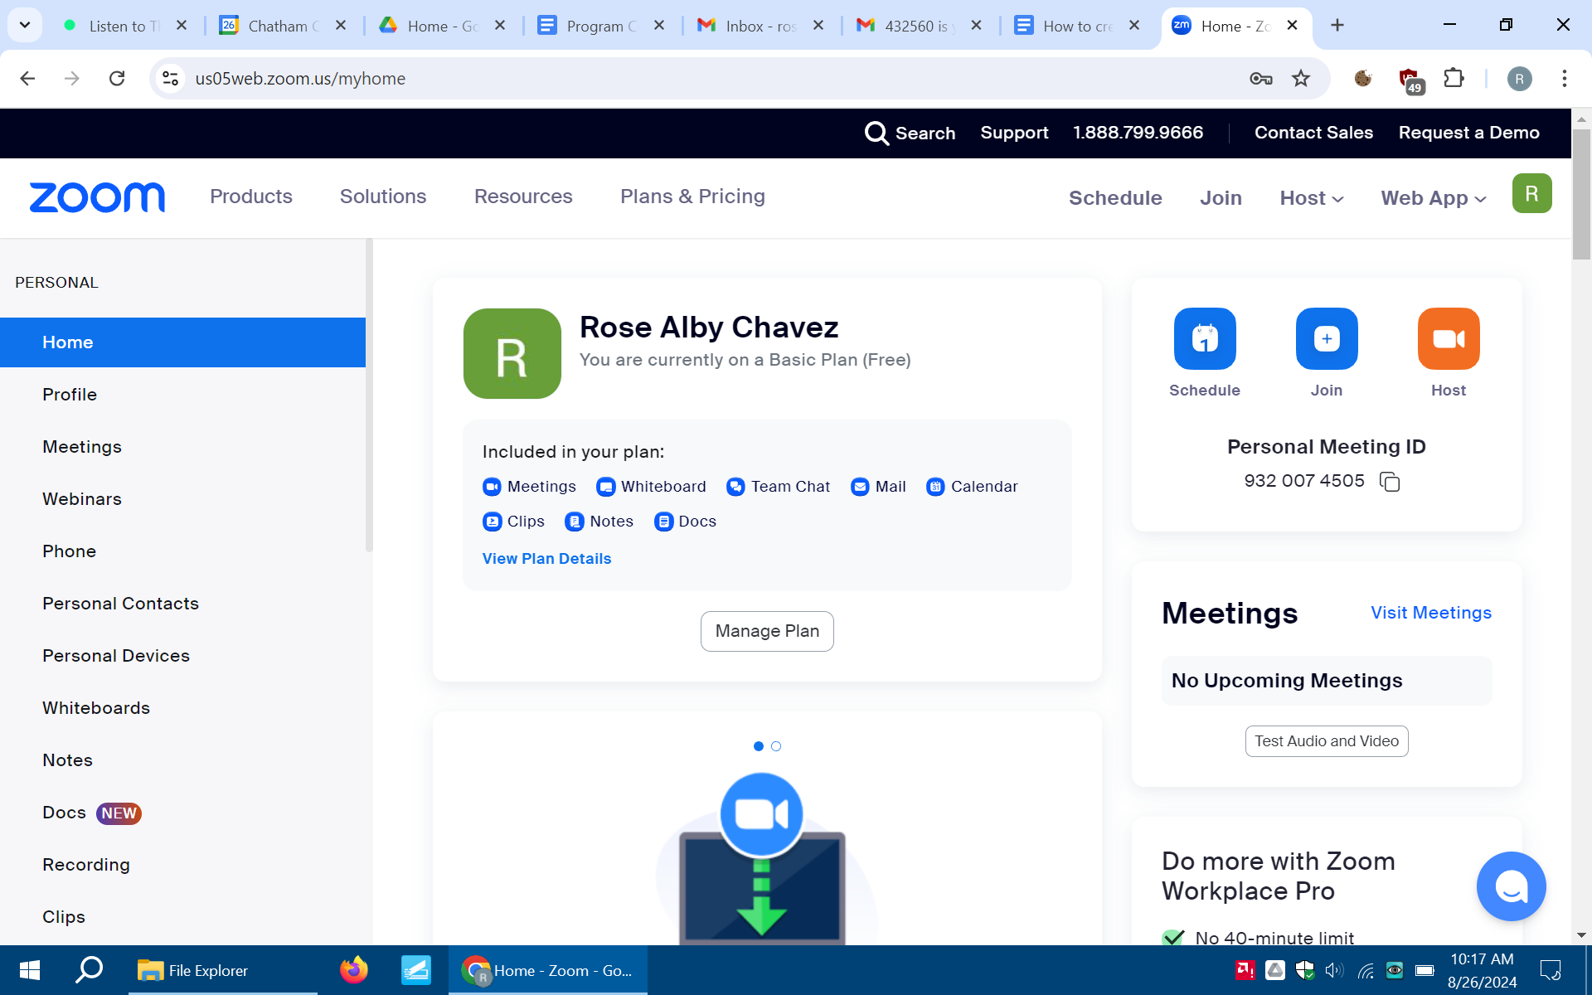

**At this time, you have completed the sign-up process for Zoom.** 😊

