How to create a Gmail account:

- Go to gmail.com
- Click, ‘create a new account’
  - A drop-down menu will appear.
  - Click on ‘for my personal use’.
  - Click the blue ‘next’ button in the bottom right hand corner.
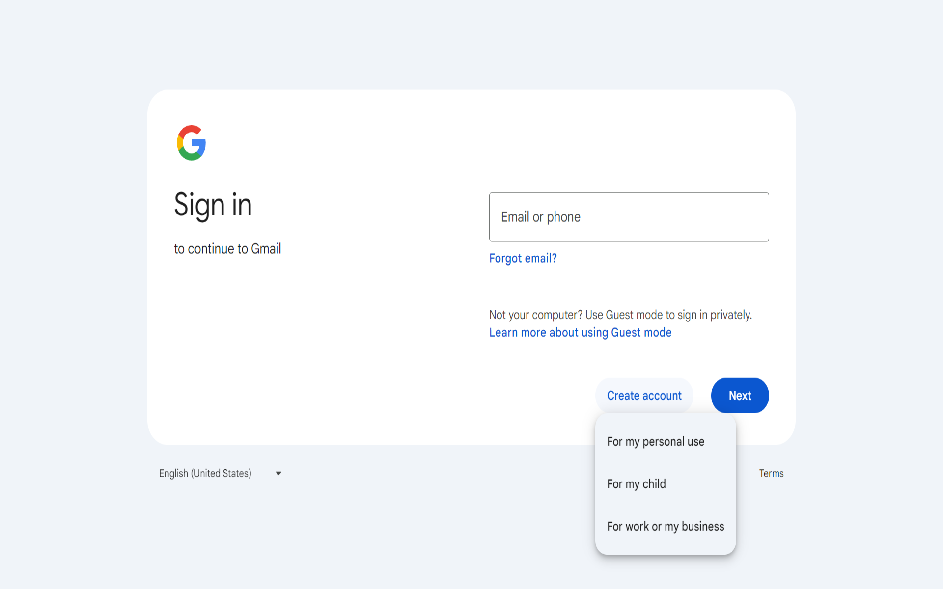
- Type in your first and last name.
  - Click the blue, ‘next’ button in the right hand bottom corner to proceed.
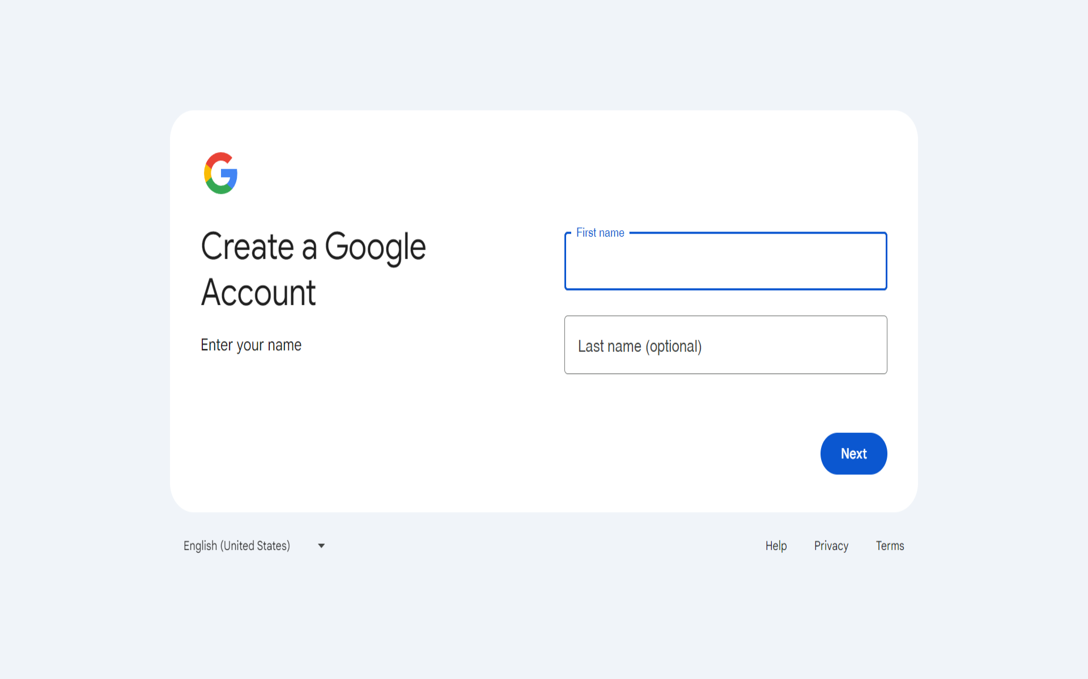
- Next, type in your birthday and gender.
  - Click the blue, ‘next’ button to proceed.
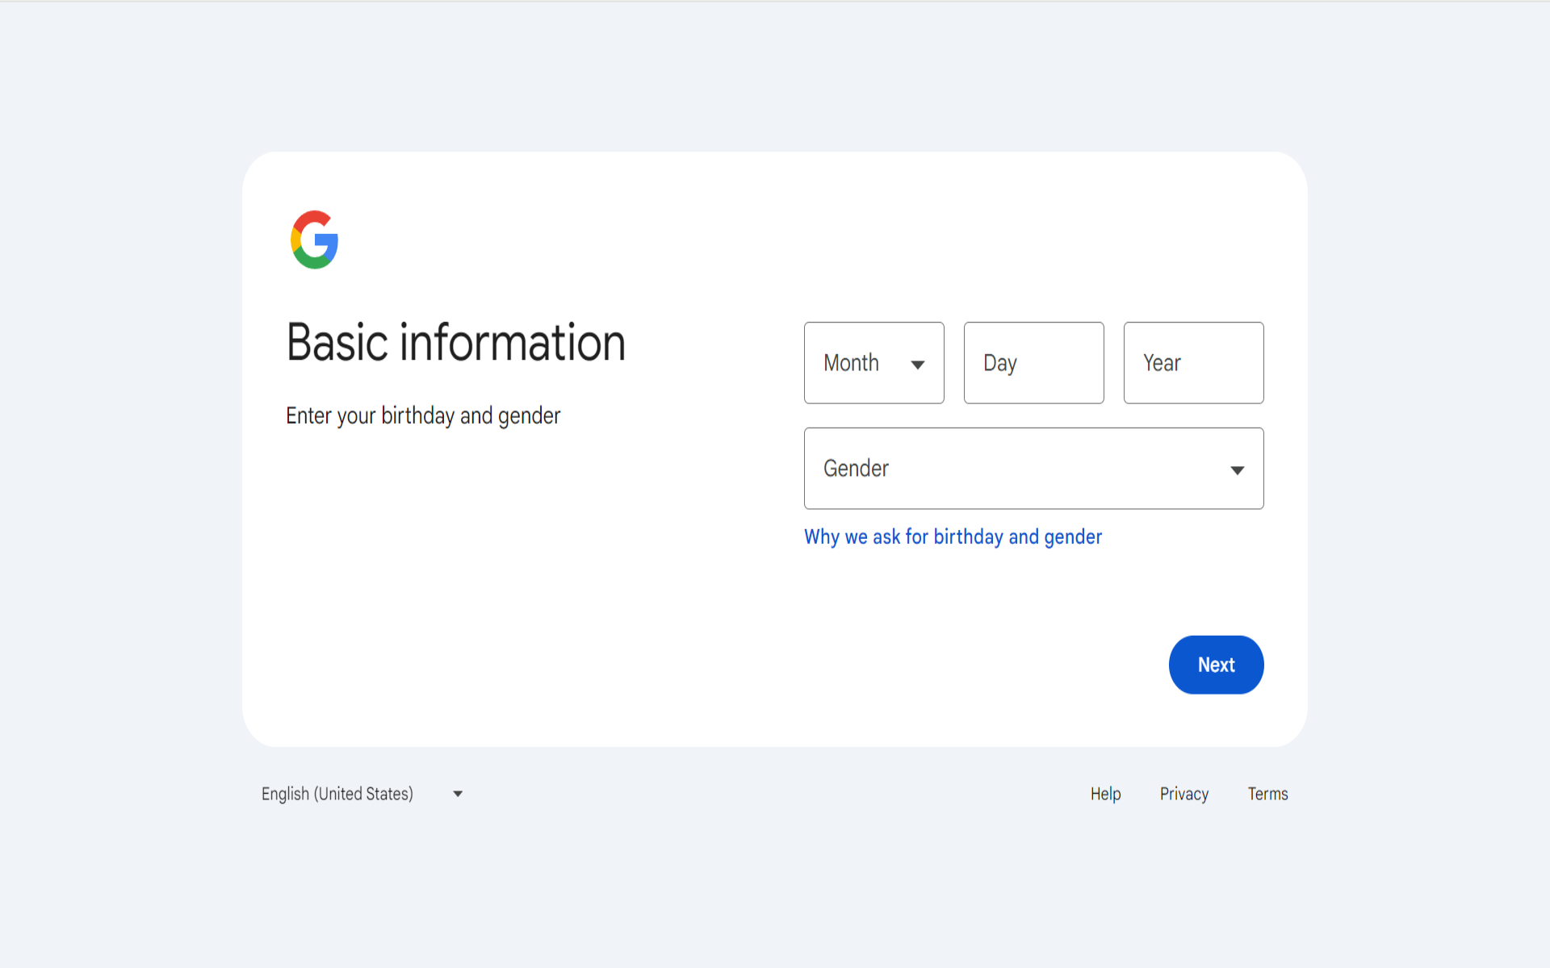
- Next, choose your email address.
  - You can use the suggestions based on your first and last name OR create your own unique gmail.
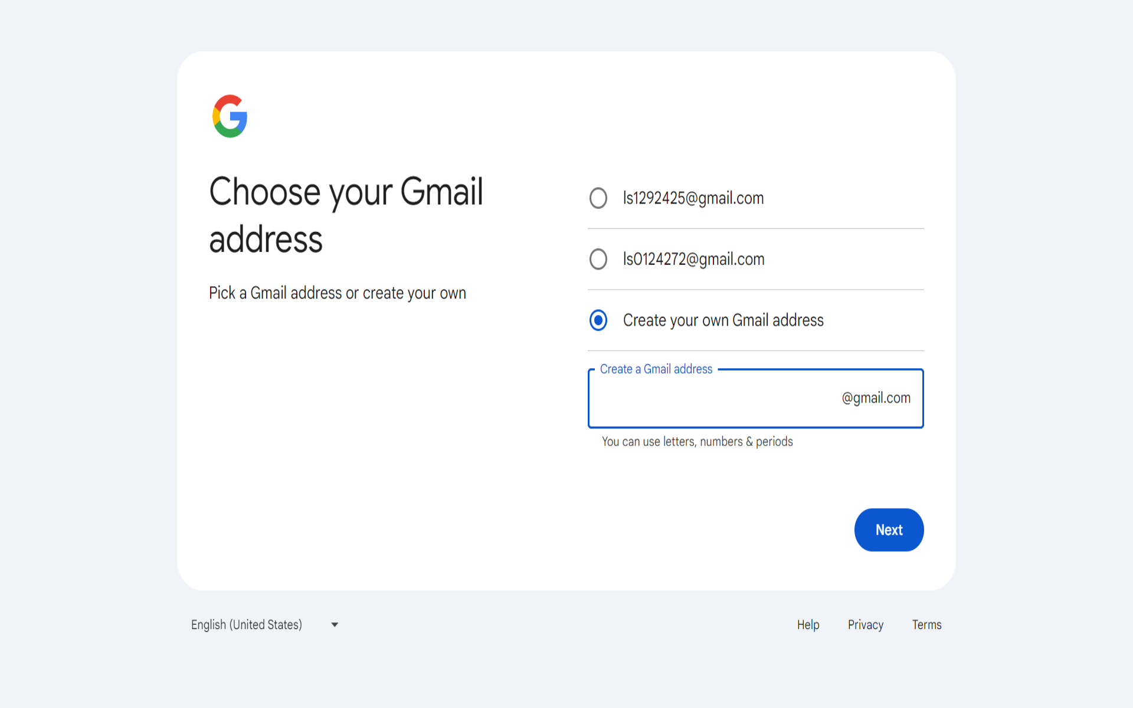
- Lastly, create a password for your gmail account
  - Click the blue, ‘next’ button once finished.
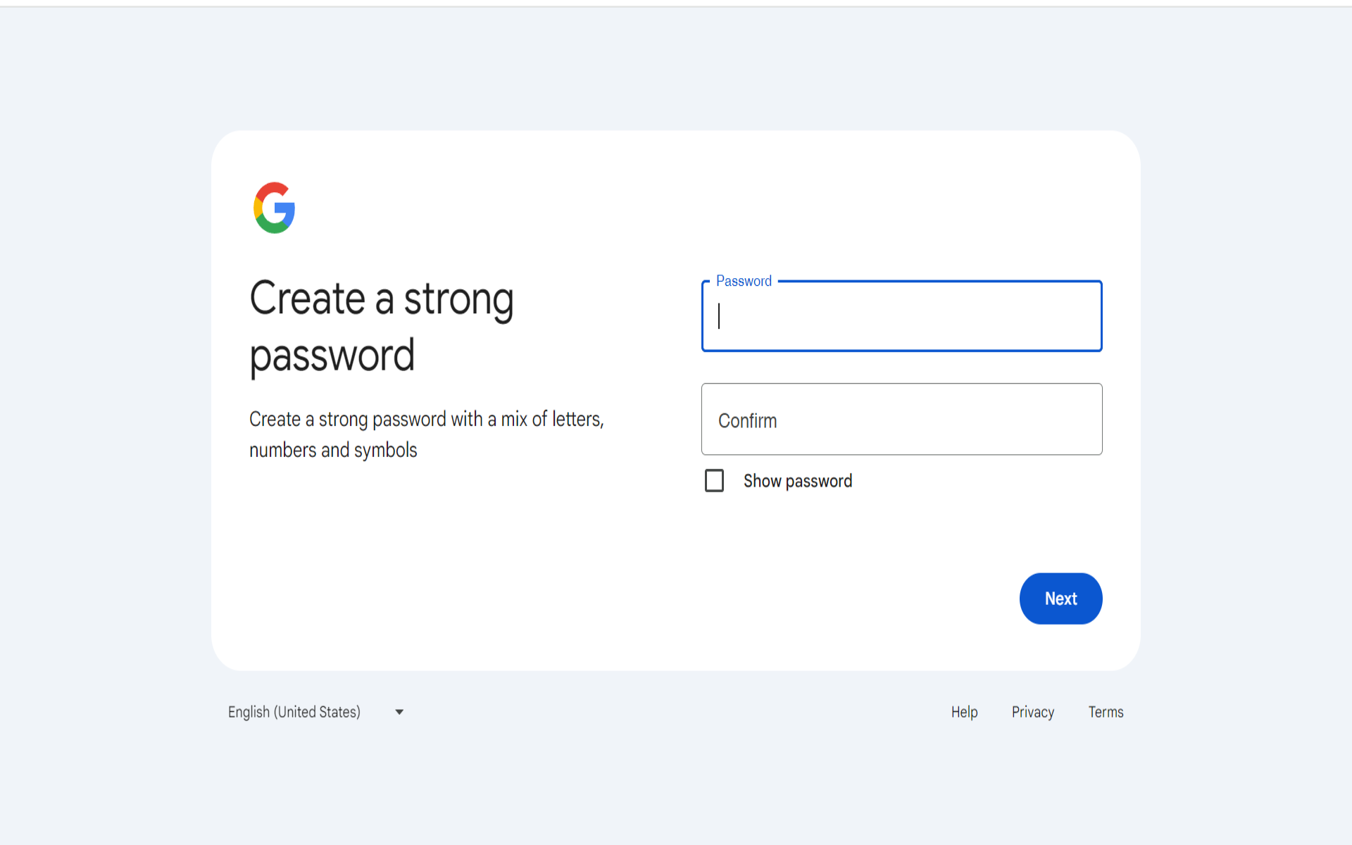
- The next page is going to ask you to add a recovery email.
  - If you would like to you may add one, otherwise click the ‘skip’ button on the bottom, left hand side.
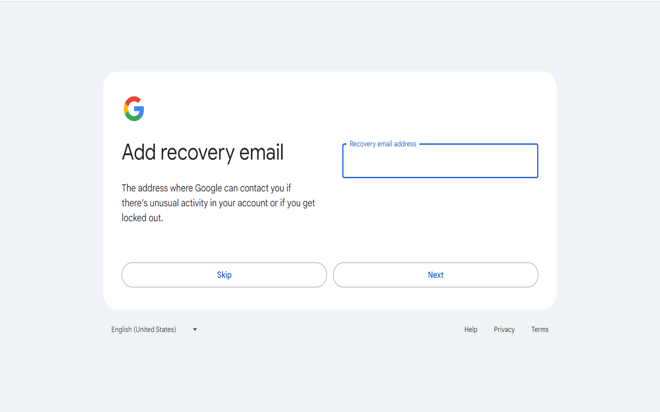

- Next, you will be asked to review your account information.
  - Click the blue, ‘next’ button once finished.
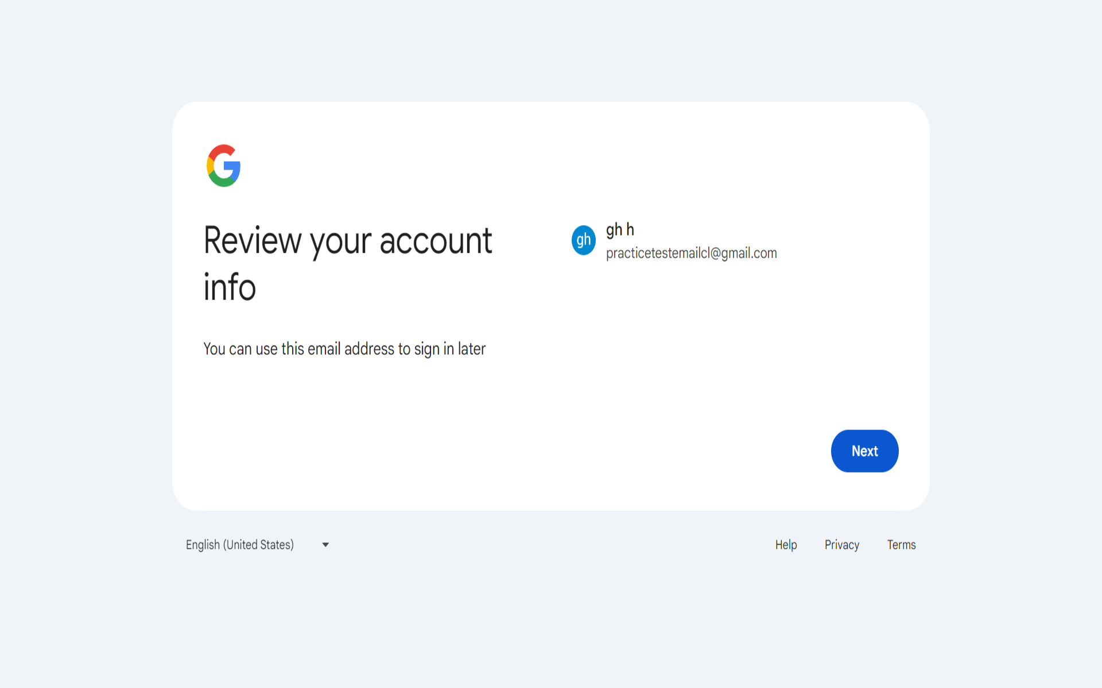
- Privacy and Terms condition agreement will pop-up.
  - As you are reading, scroll to the bottom.
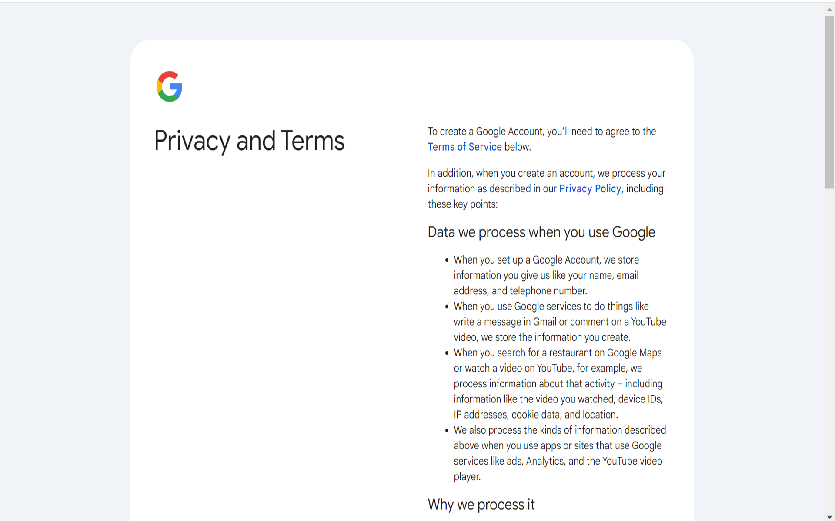
- Once you are finished reading, click the, ‘I agree’, blue button in the right hand bottom corner.
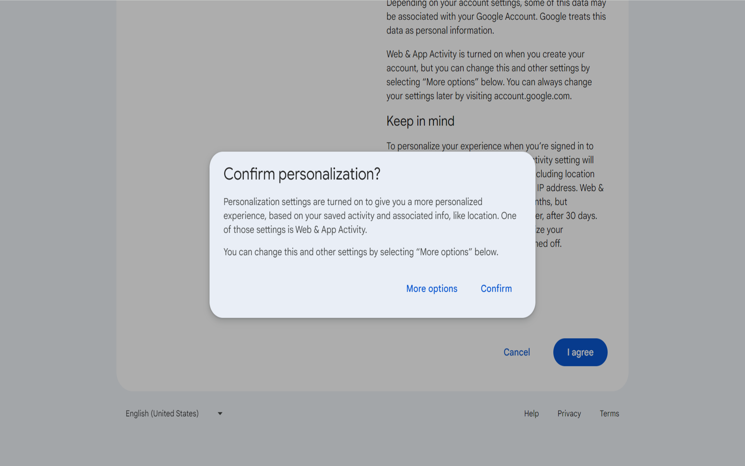

- Upon completion, you will be redirected to the google homepage with the search bar. If you look to the right, there is a button with your initials.
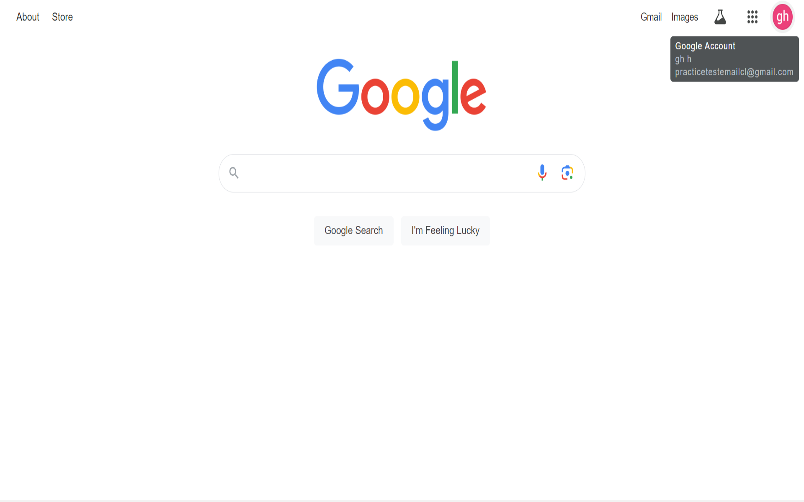

**At this point, your email should be created and you are free to explore google suite tools. 🙂**

