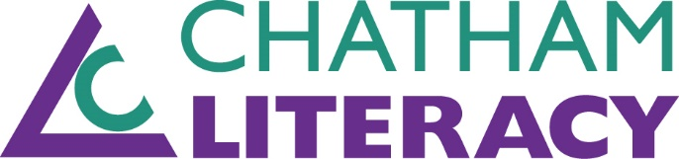

REGISTRATION FORM

RAFFLE TICKET
WHAT: Win a trip for two to Tuscany ($5,000 value. No cash value)
WHEN: Raffle tickets available between February 1 - April 10, 2019 or until sold out
WHERE: Drawing on April 10 at the Spring for Literacy Luncheon (you do NOT need to be present to win)
COST: $100 per raffle ticket (up to 250 tickets will be sold)

Name:

Address:

Phone: Email:

# of raffle tickets:

My raffle ticket donation @ $100 per ticket:

RAFFLE TICKETS AVAILABLE
ONLINE at www.chathamliteracy.org
CALL 919-542-6424
MAIL TO Chatham Literacy, P.O. Box 1696, Pittsboro, NC 27312

Chatham Literacy is a nonprofit organization whose mission is to help adults, living or working in Chatham County, N.C., acquire the literacy and educational skills they need to function successfully in society.

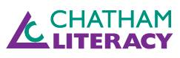
FOR MORE INFORMATION:
Vicki Newell, Executive Director
Vicki@chathamliteracy.org
919.542.6424

